Historical Thinking Assessment

SUPPORT/
JUSTIFY
Back up, justify with evidence.
Provide proof or evidence for something.

EVALUATE
Make a judgment, place a value on.
Decide the worth of something.

ANALYZE
Break something down into parts.
Separate into parts for close study; examine and explain.

Background
In 7th grade Social Studies, we have studied World History during the Middle Ages. Historians mark the beginning of the Middle Ages with the fall of the Roman Empire around the year 500. The Renaissance and the Age of Discovery around the year 1500 mark the end of the Middle Ages. Columbus landed on Hispaniola on October 12, 1492 and marks one of the significant events that mark the end of the Middle Ages. Monuments to Christopher Columbus in the United States have both honored Columbus’ achievements and generated controversy.
The oldest monument to Christopher Columbus is in Baltimore City. The Columbus Obelisk was given to Baltimore in 1792 to commemorate the 300th anniversary of his voyage. In August of 2017, vandals tried to destroy the Columbus Obelisk with a sledgehammer.
Cities have had to deal with controversial statues recently. Cities like New York have decided to either relocate or remove statues, replace statues with new artwork, or provide information to the public to provide historical context. Baltimore has decided to keep the Columbus Obelisk in place and add information on a plaque.
Your Task: You will source and corroborate (or analyze, evaluate) the primary and secondary documents provided to determine which of the two images below provides the best historical context of Christopher Columbus. You will notify the public of the image you have chosen by posting on the Columbus Obelisk Instagram page. Your post will inform the public, why you chose the image, and what sources you used to make your decision. You will cite your sources and provide an explanation on how your source supports the image you chose. In your post include other facts that should be included with the Columbus Obelisk to provide a context of the impact of Columbus in the United States.

How does the image you chose best inform the public about Christopher Columbus?
Image 1
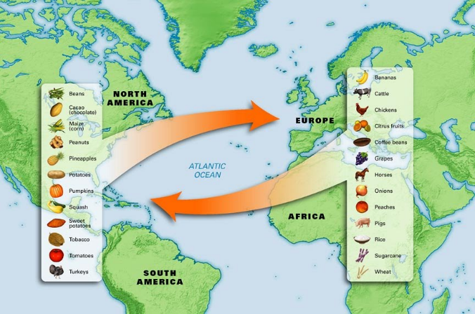
Image 2
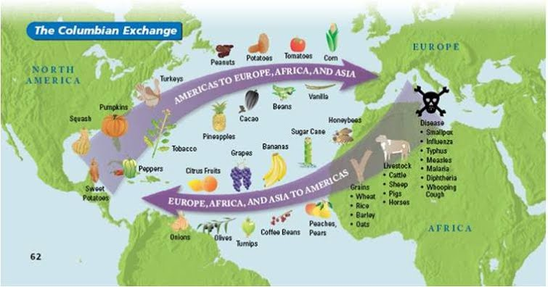

Source A
The drawing is taken from the 16th-century Florentine Codex (compiled 1540–1585 by a Spanish Friar, drawn by American Natives), showing Nahuas of conquest-era central Mexico suffering from smallpox.

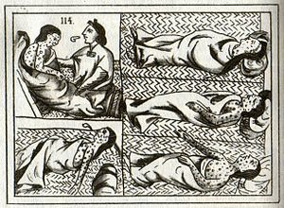

Scholars now believe that among the various contributing factors, epidemic disease was the overwhelming cause of the population decline of the American Natives. After first contacts with Europeans and Africans, some believe that Old World diseases caused the death of 90 to 95% of the native population of the New World.

Source B
Engraving, based on a drawing made by John White (mapmaker, English Governor of Roanoke Island) in the 1580s.
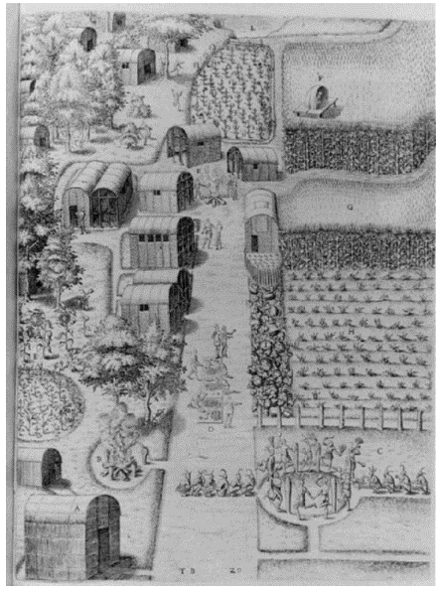

Engraving shows careful management and use of the land. Crops include tobacco and pumpkins, corn in three stages of growth, and sunflowers, while domesticated deer graze in the adjoining woods. The buildings include family units and storehouses for the surplus corn. The people of Secotan lived in permanent villages near today's North Carolina Outer Banks. Like the northern Algonquians, they farmed collectively in the growing season and dispersed into family units to hunt during the colder months.

Source C
Sheet from the Huejotzingo Codex drawn by American Natives in 1531 to show Spanish influence.

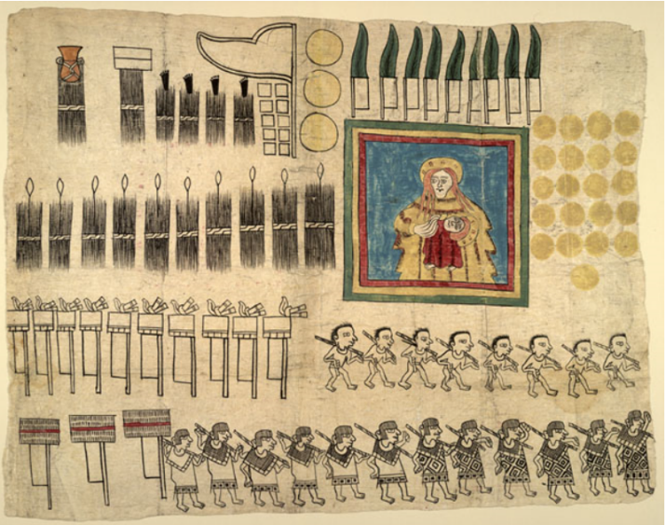

Citation: The sheet shows products and services provided as tribute, including a banner with Madonna and Child. The Europeans brought technologies, ideas, plants, and animals The Europeans brought technologies, ideas, plants, and animals that were new to America and would transform peoples' lives: guns, iron tools, and weapons; Christianity and Roman law; sugarcane and wheat; horses and cattle.

Source D
Quote from Columbus Journal, October 1492

“They…brought us parrots and balls of cotton and spears and many other things, which they exchanged for the glass beads and hawks’ bells. They willingly traded everything they owned….They were well-built, with good bodies and handsome features….They do not bear arms, and do not know them, for I showed them a sword, they took it by the edge and cut themselves out of ignorance. They have no iron. Their spears are made of cane….They would make fine servants….With fifty men we could subjugate them all and make them do whatever we want.”

Source D
Excerpt from President Ronald Reagan, October 9, 1981 Columbus Day Proclamation speech

He is justly admired as a brilliant navigator, a fearless man of action, a visionary who opened the eyes of an older world to an entirely new one. Above all, he personifies a view of the world that many see as quintessentially American: not merely optimistic, but scornful of the very notion of despair.
Nearly five centuries have passed since the fateful day on which Columbus changed the course of history. But his adventurous spirit lives on among us, challenging us to emulation and abiding with us as we too press forward on our voyage of discovery.
In tribute to the achievement of Columbus and to the many sons and daughters of Italy who have helped to shape our life and destiny as a people, the Congress of the United States of America has requested the President to proclaim the second Monday in October of each year as Columbus Day.

Source E
Excerpt from President Barack Obama, October 10, 2016 Columbus Day Proclamation speech

Though Columbus departed from the coast of Spain, his roots traced back to his birthplace of Genoa, Italy. Blazing a trail for generations of Italian explorers and Italian Americans to eventually seek the promise of the New World, his voyage churned the gears of history. The bonds between Italy and the United States could not be closer than they are today -- a reflection of the extraordinary contributions made by both our peoples in our common efforts to shape a better future. Across our Nation, Italian Americans continue to enrich our country's traditions and culture.
As we mark this rich history, we must also acknowledge the pain and suffering reflected in the stories of Native Americans who had long resided on this land prior to the arrival of European newcomers. The past we share is marked by too many broken promises, as well as violence, deprivation, and disease. It is a history that we must recognize as we seek to build a brighter future -- side by side and with cooperation and mutual respect. We have made great progress together in recent years, and we will keep striving to maintain strong nation-to-nation relationships, strengthen tribal sovereignty, and help all our communities thrive.

Source F
Results from Rasmussen telephone survey October 14, 2013.

Christopher Columbus is widely regarded as the explorer who discovered America, immortalized for elementary school students in the rhyme, “In 1492, Columbus sailed the ocean blue.” That line seems to have stuck with adults since most think America should still honor Columbus with a national holiday.

A new Rasmussen Reports national telephone survey finds that 58% of American Adults think we should still celebrate Columbus Day which officially falls today. One-in-four adults (26%) disagree, and 16% are not sure.

Source G
Excerpts from the fictional picture book “Encounter” by Jane Yolen published by Harcourt Brace Jovanovich, [1992] ©1992. A Taino Indian boy on the island of San Salvador recounts the landing of Columbus and his men in 1492.

“But in my dream that night, three great-winged birds with voices like thunder rode wild waves in our bay. They were not like any birds I had ever seen, for sharp, white teeth filled their mouth.”

“Our chief gave the strangers balls of cotton thread to bind thus to us in friendship. He gave them spears that they might fish and not starve. He gave them gum-rubber balls for sport. He gave them parrots, too-which made our young men laugh behind their hands all over again, knowing it was our chief’s little joke, that the strangers looked like parrots.”

“... I watched how the sky strangers touched our golden nose rings and our golden armbands but not the flesh of our faces or arms. I watched their chief smile. It was the serpent’s smile—no lips and all teeth. I jumped up, crying, ‘Do not welcome them!’ But the welcome had already been given.”

“That night while my people slept on shore, the great-sailed canoes left our bay, going farther than even our strongest men could go. Soon the beach and trees and everything I knew slipped away, until my world was only a thin, dark line stretched between sky and sea. What else was there to do?

Source H
Excerpt from the article Columbus’ Confusion About the New World, Smithsonian.com October 2009.

For the Arawaks the new system of forced labor meant that they did more work, wore more clothes and said more prayers. Peter Martyr could rejoice that "so many thousands of men are received to bee the sheepe of Christes flocke." But these were sheep prepared for slaughter. If we may believe Bartolomé de Las Casas, a Dominican priest who spent many years among them, they were tortured, burned and fed to the dogs by their masters. They died from overwork and from new European diseases. They killed themselves. And they took pains to avoid having children. Life was not fit to live, and they stopped living. From a population of 100,000 at the lowest estimate in 1492, there remained in 1514 about 32,000 Arawaks in Española. By 1542, according to Las Casas, only 200 were left. In their place had appeared slaves imported from Africa. The people of the golden age had been virtually exterminated.

Cities have had to deal with controversial statues recently. Cities like New York have decided to either relocate or remove statues, replace statues with new artwork, or provide information to the public to provide historical context. Baltimore has decided to keep the Columbus Obelisk in place and add information on a plaque. Source and corroborate (or analyze, evaluate) the primary and secondary documents provided and decide which of the following images to use to provide historical context of Christopher Columbus. Notify the public of the new image by posting on the Columbus Obelisk Instagram page. The post of the image is to inform the public, why you chose the image, what sources you used to make your decision. Also, in your post, include other facts that should be included with the Columbus Obelisk to provide a context of the impact of Columbus in the United States.
Image 1
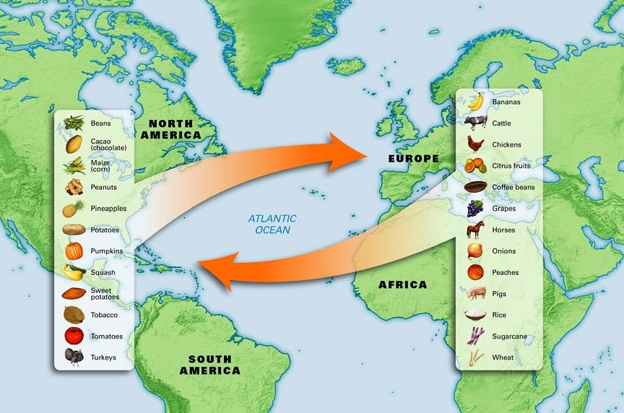
Image 2
_____________________________________________________________________________________________________________________________________________________________________________________________________________________________________________________________________________________________________________________________________________________________________________________________________________________________________________________________________________________________________________________________________________________________________________________________________________________________________________________________________________________________________________________________________________________________________________________________________________________________________________________________________________________________________________________________________________________________________________________________________________________________
The Columbus Obelisk
Circle One

Image 1

Image 2

Write caption with hashtags below.
…

